# Volvo Group – the third quarter 2022

2022-10-20

“In Q3 2022, the Volvo Group’s strong growth continued. We increased our net sales by 35% to SEK 114.9 billion with a good development both in the sales of vehicles and in the service business. The adjusted operating income rose to SEK 11.9 billion (9.4) with an adjusted operating margin of 10.3% (11.0). A reduction in working capital contributed to a strong operating cash flow of SEK 14.6 billion (-5.7) in Industrial Operations. Return on capital employed improved to 27.4% (25.6),” says Martin Lundstedt, President and CEO.

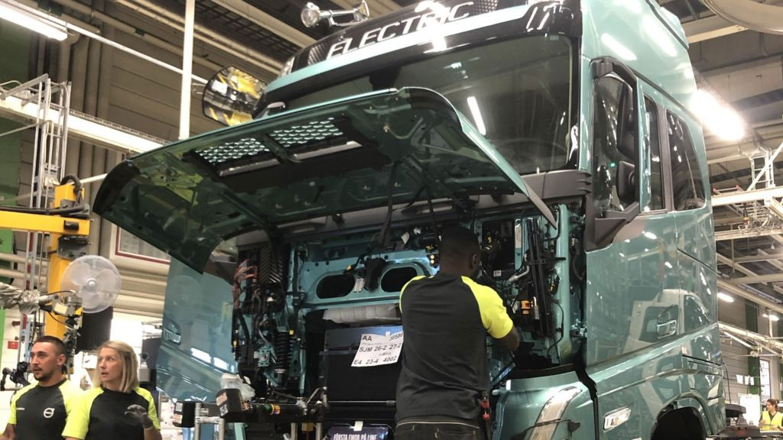

* In Q3 2022, net sales increased by 35% to SEK 114.9 billion (85.3). Adjusted for currency movements the increase was 21%.
* Both adjusted and reported operating income amounted to SEK 11,869 M (9,403), corresponding to an operating margin of 10.3% (11.0).
* Currency movements had a positive impact on operating income of SEK 2,417 M.
* Earnings per share amounted to SEK 4.24 (3.47).
* Operating cash flow in Industrial Operations amounted to SEK 14,611 M (-5,735).
* Return on capital employed in Industrial Operations amounted to 27.4% (25.6).
* Series production of heavy-duty, 44-tonne electric trucks started.

Press and Analyst Conference Call. An on-line presentation of the report, followed by a question and answer session will be webcast starting at 09.00 CET.

More information, including an interview with CEO Martin Lundstedt, is available on <https://www.volvogroup.com/en/investors.html>

This information is information that AB Volvo (publ) is obliged to make public pursuant to the EU Market Abuse Regulation and the Securities Markets Act. The information was submitted for publication, through the agency of the contact person set out above, at 07.20 CEST on October 20, 2022.